**Session 8**

**04/06/2021**

**Problem Statement:**

**Using the Sales.csv file, create a database called “salesdb”. Create a table under that with the heading “sales”. (Adjust the rows by looking at the csv file columns.)**

**Dataset**

<https://docs.google.com/spreadsheets/d/1A5qe2j0DkqwNM5sZ7qV44SyxjR2Woj1K-BZG573YjOc/edit?usp=sharing>

**Perform the following Queries using HiveQL:**

* **Insert 5 records using the Insert command in HiveQL.**
* **Import the dataset from the sales.csv file.**
* **count the number of sales done by each country.**
* **Count the number of sales done by each state.**
* **Display (Product, name) grouped by product.**
* **Create separate views for VISA and Mastercard.**
* **show all the transactions done in Seattle.**
* **Find the max number of transactions done within the state of Ontario.**
* **Find the number of transactions whose price is between 1500-3600**
* **List all the transactions done in the United States using Mastercard.**

**Start HIVE**



1. **Create a Db called salesdb**

* Create database salesdb;
* Use salesdb;



1. **Create a table under that with the heading “sales**

* > create table sales(Product string,Price int,Payment_type string,Name string, City string,State string,

Country string)

> row format delimited

> fields terminated by ",";



1. **Insert Data From the CSV file Given**

* LOAD DATA local INPATH "/home/hadoop/sales.csv" into table sales;

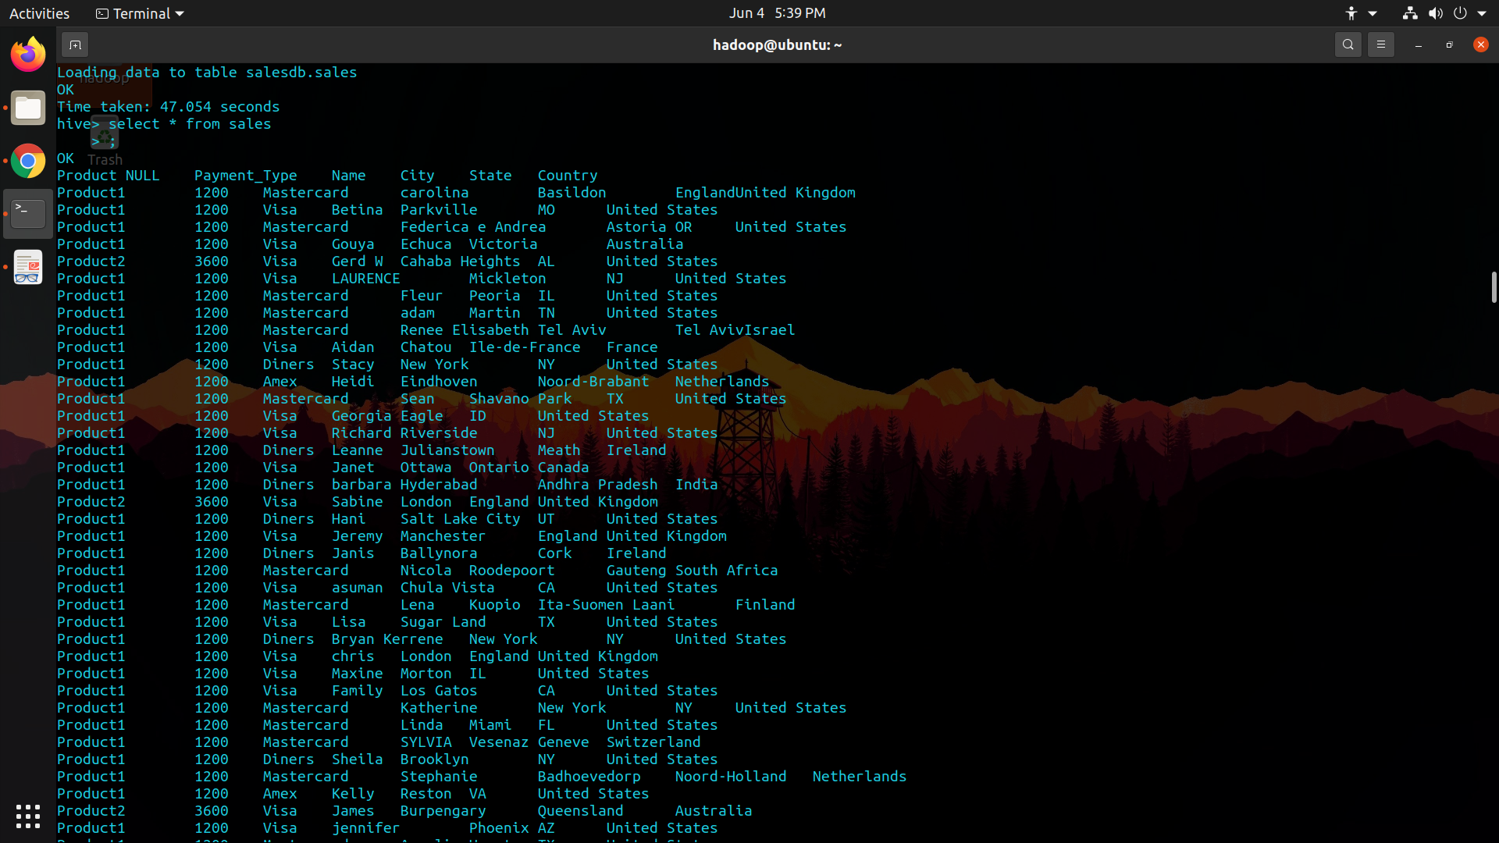

1. **Insert 5 records into the Salesdb**

* $ insert into sales

> values

> ("Product1", 2500, "Rupay", "Umesh", "Thirupathi", "Andhra", "India"),

> ("Product2", 1000, "Mastercard", "Richard", "Yale", "Chicago", "United States"),

> ("Product3", 4000, "Visa", "Tupac", "paddington", "London", "United Kingdom"),

> ("Product2", 6800, "Rupay", “Himanshu", "Bengaluru", "Karnataka", "India"),

> ("Product3", 2600, "American Express", "Tyrion", "Dubai", "Abu Dhabi", "UAE"),

> ("Product1", 9000, "Diners", "Gukund", "Penang", "Penang Island", "Malaysia")

* select * from sales;

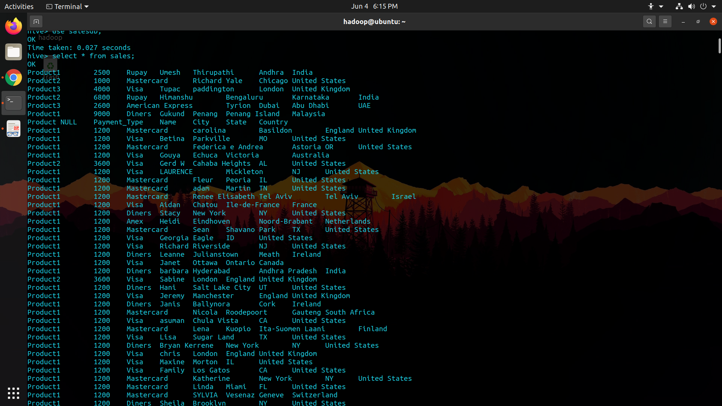

1. **Count the number of sales done by each Country**

* select country, count(country)

> from sales

> group by country;



1. **Count the number of sales done by each State**

* select state, count(state)

> from sales

> group by state;



1. **Display (Product, name) grouped by product.**

* select product, count(name)

> from sales

> group by product;

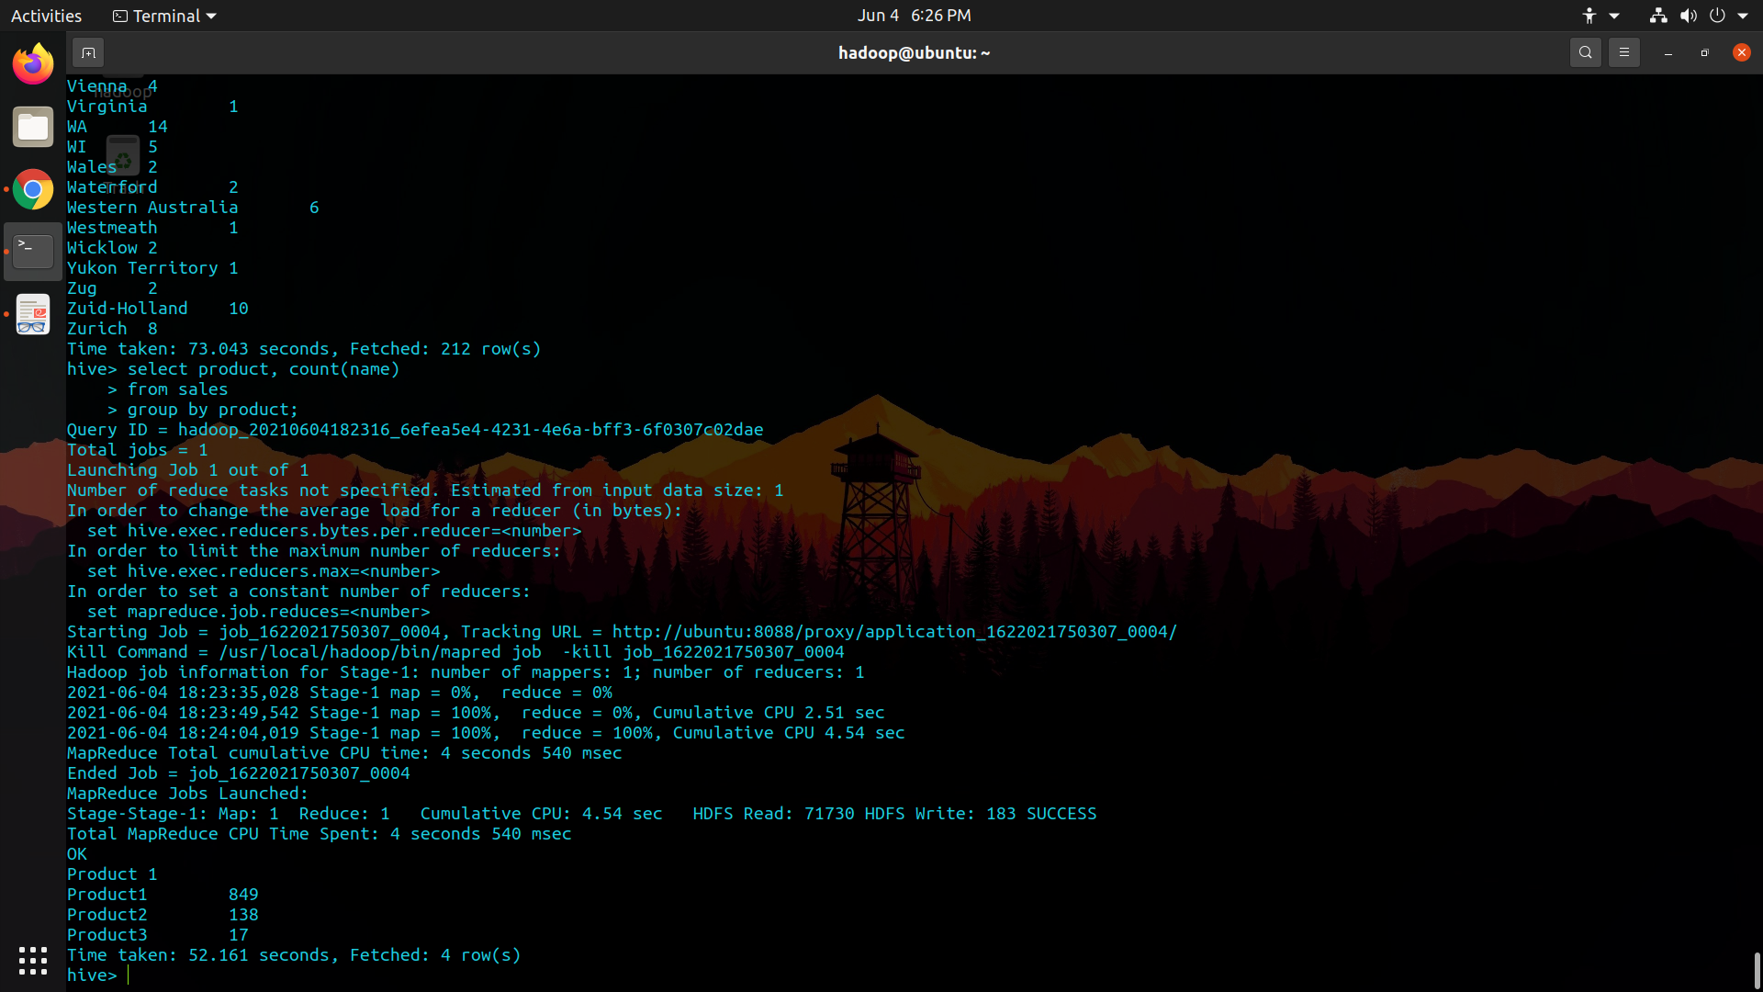

1. **Create separate views for VISA and Mastercard**

* create view VISA as

> select * from sales

> where payment_type="Visa";

* select * from VISA;

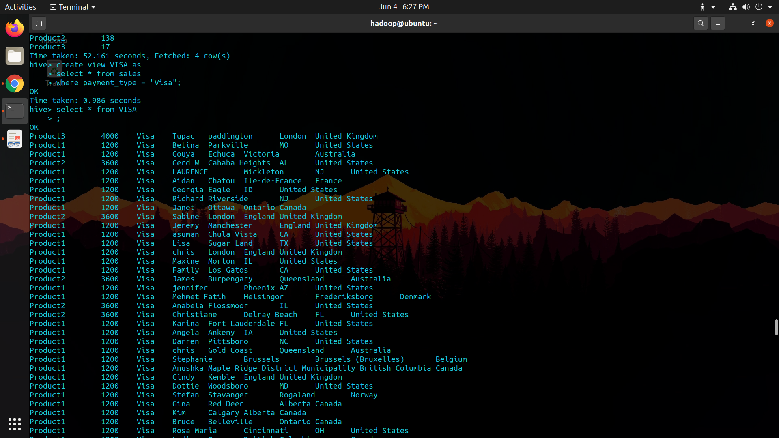

* create view MCard as

> select * from sales

> where payment_type="Mastercard";

* select * from MCard;

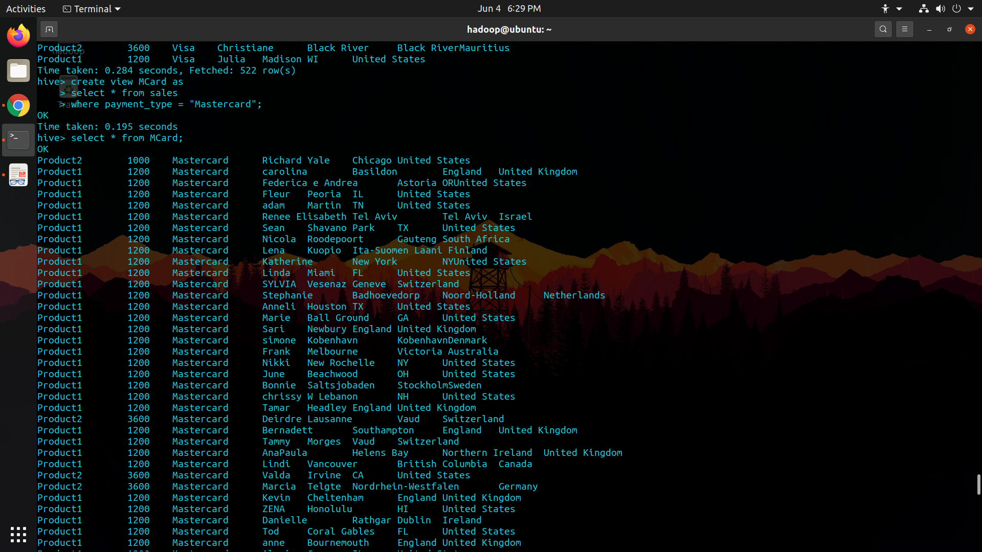

1. **Show all the transactions done in Seattle**

* select * from sales

> where city ="Seattle";



1. **Find the max number of transactions done within the state of Ontario**

* select city, count(city)

> from sales

> where state="Ontario"

> group by city

> having count(city) = (select max(c) from (select count(city) c from

sales where state="Ontario" group by city) a);

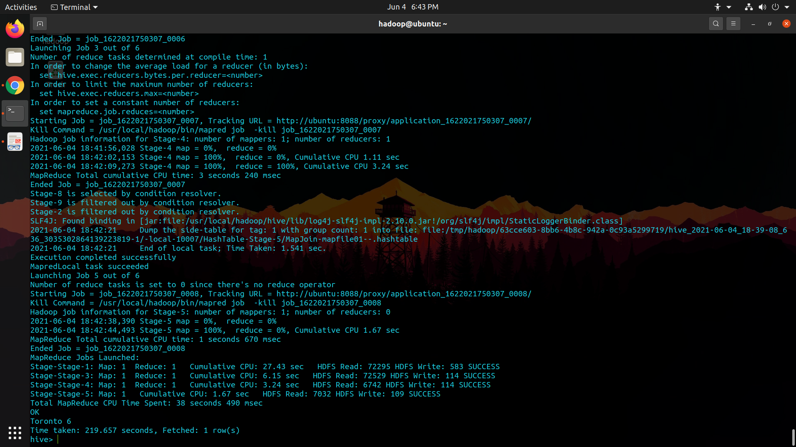

1. **Find the number of transactions whose price is between 1500-3600**

* select count(*)

from sales where price between 1500 and 3600;

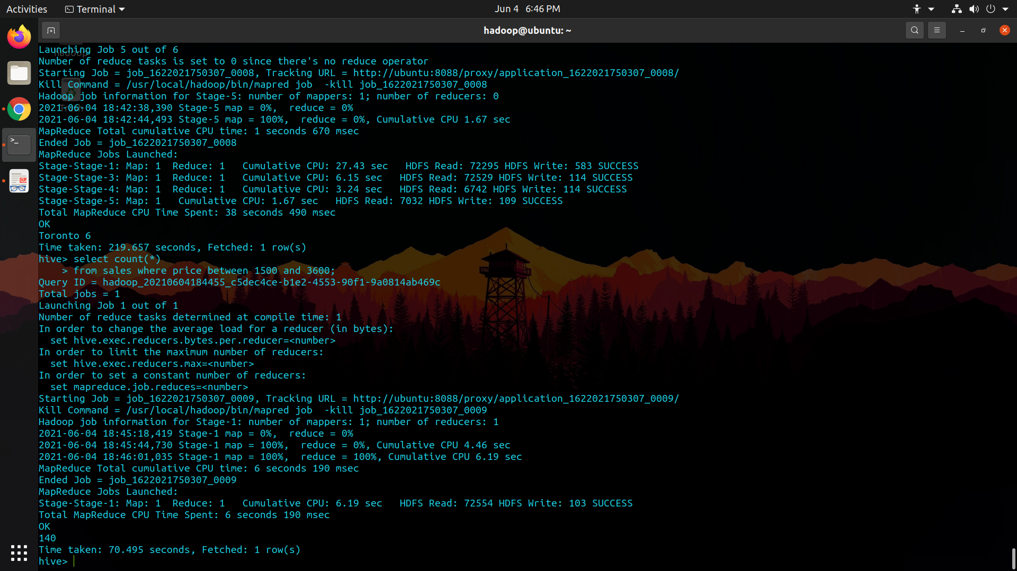

1. **List all the transactions done in the United States using Mastercard**

* select * from sales

> where country="United States" and payment_type="Mastercard";

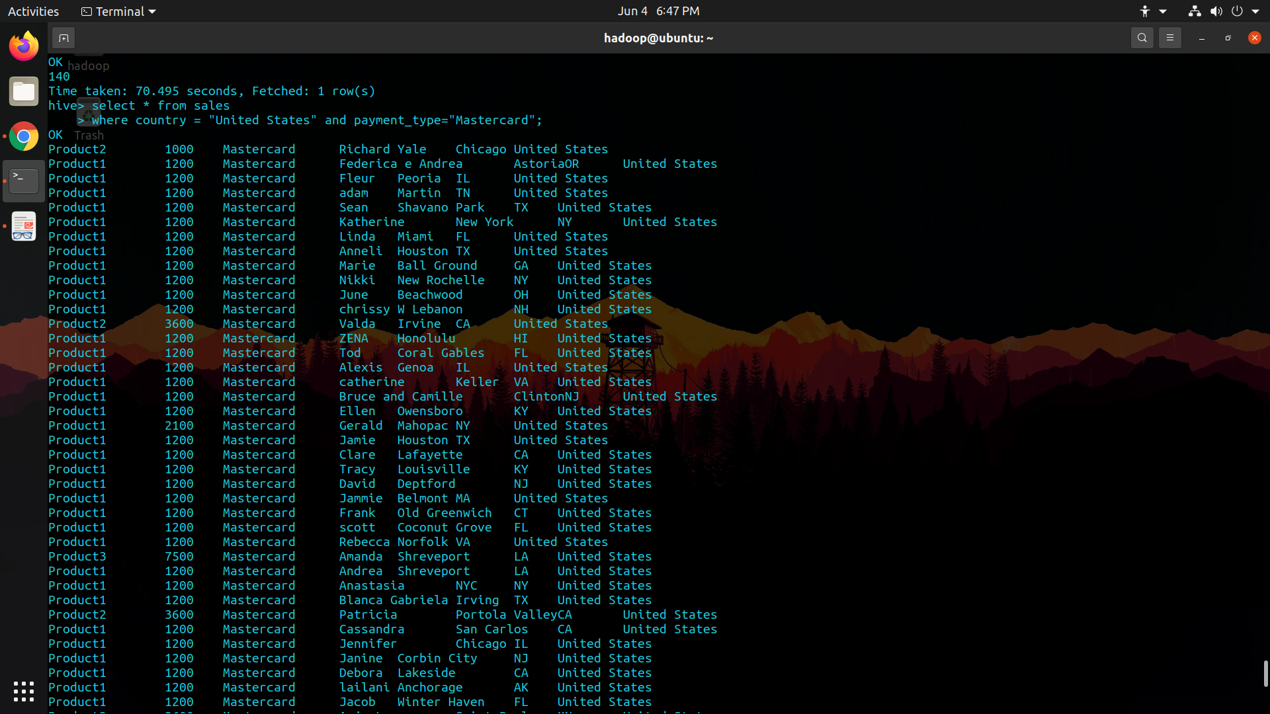

**Sriranjan S**

**1NT18IS159**